© 2022 National Council on Aging.
All rights reserved.
National Senior Center Month

Publicity Guide

September 2022
"Strengthening Community Connections"

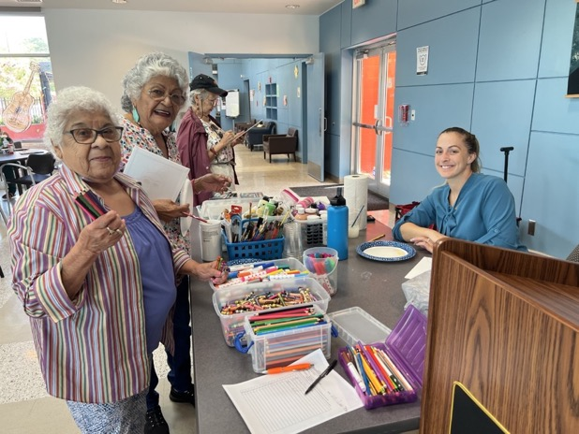

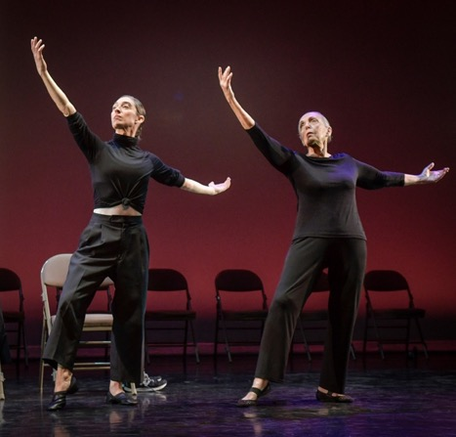

© Cynthia Abatt

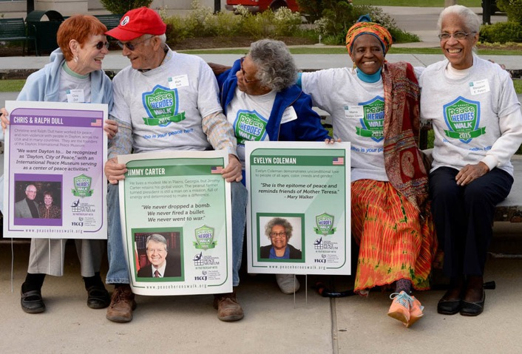

© Patsy Ferrell
© Kramer

Media Plan for
National Senior Center Month

Y
our local media is always looking for a good story about how your community is supporting older adults. This is a great time to share upbeat, empowering examples of how your center is the key to aging well with exciting virtual and in-person programs and a focus
on healthy living. We’ve made reaching out to local reporters easy. This media plan will help you generate newspaper, radio, and television interest in your center’s participation in National Senior Center Month.

1 month before your celebration . . .
- Make a list and contact reporters or outlets you want to cover your events.
- If you are creating a virtual event, make sure it will be easily accessible to media,
and they can record or have same-day access to a high-definition recording of the event.
- Ensure your spokespeople and participants will be available in person (in a safe manner) or virtually for media interviews.
FOR NEWSPAPERS:
- Find out which editor or reporter covers community events. Is there another reporter who covers issues specifically relating to seniors or families? Note the reporter’s name, email address, and phone number.
- Find out if your local and/or community newspapers accept calendar announcements. Note where to send the announcement, the information to include, and how far in advance the paper needs to hear from you.
FOR RADIO AND TELEVISION:
- Collect phone numbers and email addresses for the station assignment editor.
- Call and ask for the phone number and email address for the producer of the particular show on which you would like to appear. (Tip: Generally, local news stations include community, non-policy issues in the morning show and in the early evening newscast.)
- If your local stations have a local lifestyle show, it may have a different booker for guests or stories. Check their website for contact information. Also consider asking their host if they would participate in one of your activities (if appropriate).
- Ask if the station or website accepts calendar announcements. Find out where to send them, what information you should include, and how far in advance the station needs the information.
- Inform the staff of local elected officials of your celebration. Consider calling or emailing your governor’s office, U.S. House and Senate offices, state offices, mayor, city council, etc., to invite them to support your senior center and its virtual or on-site programming. You can get their contact information on NCOA’s website.
  - Go to NCOA’s Policy Action Center and enter your ZIP code in the "Find your Elected Officials" search tool at the bottom of the page. Enter the full address of your center for a list of officials that represent just the area of your center.

- Click on the name to view their contact information. Call their local office and ask for the staff person responsible for letters of support.
- Write a letter to the official and email it to the appropriate staff person.
- Follow up with a call or email to the staff member you sent the letter to. When discussing the letter of support, consider offering to include an article and photo of the letter of support in your next newsletter or provide a plaque thanking the member of Congress for supporting your senior center.

3 weeks before your celebration . . .
- Evaluate your media contacts. Determine which contacts you want to personally invite to cover your celebration (this is often called pitching), which contacts you want to invite with a media advisory, and if there are any you only want to alert about your participation in National Senior Center Month with a press release.
- Send out your calendar announcements. Use the samples included in this guide and distribute them to local media based on the list you’ve collected.
- Pitch important media. Use the sample pitch included in this guide to begin approaching specific reporters and assignment editors about doing a story on senior centers. Remember, you must give them a good story idea and all the elements to tell the story to get them interested.
- Prepare and distribute a media advisory if you’re planning a special event. Use the Sample Media Advisory included in this guide. Send the advisory via email to the media list you’ve collected.
- Start social media promotion across your channels. Remember, you're trying to reach participants, reporters, and local influencers. Use similar messages across all the social media outlets you use, such as Facebook, Twitter, LinkedIn, Instagram, and Pinterest.
- Begin to train your staff on their roles for the celebration(s).
- Spread the word. Encourage your participants to tell their friends and families about your events. You never know who your members know—they may have an association with members of the media or legislators that will give you a head start.

10 days before your celebration . . .
- Make follow-up calls to the media contacts you pitched to see if they are planning to do a story on National Senior Center Month. Offer to help coordinate the interviews or photos they would need for a story and provide background that will help them tell the story you’ve pitched them.
- Send an email to NCOA’s Public Policy & Advocacy staff at advocacy@ncoa.org to let them know about any events at your center with public officials or their staff. They can suggest questions for you to ask members of Congress and materials for you to distribute.
- Develop a strategy to ensure a big turnout for the event, including emails and follow-up phone calls to seniors and their families.
  - Let seniors know there will be press at the event, and identify which ones would like to talk to reporters. Let the press know there will be seniors they can speak with.
  - Develop a list of specific seniors with stories to tell and connect media with them when appropriate.

1 day before your celebration . . .
- Email a final media advisory or news release to newspapers, daybooks, radio stations, and television stations. Be sure to include a phone number where reporters can reach you in the evening or early morning.
- Make follow-up calls to the media you invited personally to see if they are planning to cover your event, if they haven’t already committed to attending.

Your celebration day!
- Carry your cell phone or check your messages frequently. Often media outlets don't decide until the last minute whether to cover your event.
- Assign a staff person to “meet and greet” reporters. This person will also be responsible for helping the reporter arrange any interviews or photo opportunities.

After the event . . .
- Phone or email reporters to thank those who covered National Senior Center Month or one of your events. You can also use this opportunity to offer to be a resource for future stories about aging in your community or aging policy stories.
- Compile your stories, articles, and photos in a special section on your senior center website to highlight the accomplishments of your celebration.
- Share your success! Send links to your media coverage to Simona Combi, Public Relations Manager, at simona.combi@ncoa.org and Binod Suwal, Senior Manager, NCOA Center for Healthy Aging, at binod.suwal@ncoa.org.

Media Tools

Sample Calendar Announcement
Below is a template calendar announcement you can send to your local newspaper, TV station, online publication, or municipal office to be included in their local calendar. Typically, you will need to send announcements at least 2-3 weeks before an event.
Including a list of invited special guests can help increase media interest in an event. If you don’t have a commitment from all the special guests, but you have a pretty good indication they will attend, you can say “Mayor Jon Smith (invited)” on your materials.

Fill in the indicated information. If there is any information you don’t want to include, be sure to delete the template information.
Contact:
[YOUR FULL NAME]
[TITLE]
[SENIOR CENTER]
[CELL PHONE
[EMAIL]
[SENIOR CENTER] is celebrating National Senior Center Month this September, with the 2022 theme “Strengthening Community Connections.” We’re celebrating how senior centers strengthen community connections by highlighting how we empower older adults to holistically age well and make mind, body, spirit, and community connections.

If you are planning multiple events:
Several activities are planned, including [LIST ACTIVITIES WITH DATES]. Create your own aging well connection!

For more information, call [PHONE] or visit [WEBSITE]. [SENIOR CENTER] is located at [STREET ADDRESS] in [CITY].

Or if you are planning one main activity:
Join us [DATE] at [TIME] for [ACTIVITY] to celebrate National Senior Center Month. Create your own aging well connection!

For more information, call [PHONE] or visit [WEBSITE]. [SENIOR CENTER] is located at [STREET ADDRESS] in [CITY].

Sample Media Advisory
Use a media advisory to highlight events you want media to attend or to promote. Email the advisory a few weeks before your event to newspapers, radio stations, and television stations and directly to the reporters on your media list who you do not want to invite with a personal email pitch. Follow up with 1-2 phone calls as the event gets closer. Also, send the advisory again the day before your event because broadcast media, such as television stations, often make decisions about what to cover on a day-to-day basis. Review it closely to make sure you’ve changed all template information before sending it to your contacts.
[YOUR LOGO OR LETTERHEAD]
MEDIA ADVISORY

[DATE]
FOR IMMEDIATE RELEASE
CONTACT:
[FULL NAME OF CONTACT]
[PHONE NUMBER]
[EMAIL ADDRESS]

[NAME OF CENTER] Celebrates National Senior Center Month with
[NAME OF EVENT]

WHAT:
[DESCRIPTION OF THE EVENT. BE SURE TO INCLUDE PLANNED ACTIVITIES, VIRTUAL LINKS, AND INTERESTING INFORMATION ABOUT THE CENTER.]
The event is in celebration of National Senior Center Month, sponsored by the National Council on Aging. We’re celebrating how senior centers strengthen community connections by highlighting how [SENIOR CENTER] empowers older adults to holistically age well and make mind, body, spirit, and community connections. Create your own aging well connection!
WHO:
[LIST OF SPECIAL GUESTS. MAKE SURE TO LIST IN ORDER OF IMPORTANCE.]
WHEN:
[DATE AND TIME OF EVENT]
WHERE:
[ADDRESS OF CENTER]

Call [PHONE NUMBER] or email [EMAIL ADDRESS] to arrange interviews and photo opportunities or get links to virtual event(s).

Sample Press Release
We encourage you to copy the following news release onto your letterhead and customize it.

[YOUR LOGO OR LETTERHEAD]
FOR IMMEDIATE RELEASE

CONTACT:
[FULL NAME OF CONTACT]
[PHONE NUMBER]
EMAIL ADDRESS]

Seniors in [CITY] Empowered to Age Well During National Senior Center Month
[NAME OF CENTER] delivers vital connections for older adults

[City, State] ([Date])—Today’s senior centers are delivering vital connections to help all older adults age well. Senior centers offer a vibrant, action-packed combination of [DESCRIBE 3 MAIN PROGRAMS or VIRTUAL PROGRAMS, FOR EXAMPLE: local fitness center, job and volunteering headquarters, transportation hub, and tasty dining locale].
During the pandemic, senior centers have pivoted to provide [DESCRIBE 3 CURRENT PROGRAMS, FOR EXAMPLE: online fitness, fun activities, support groups, and grab and go meals.] September is National Senior Center Month, and [NAME OF CENTER] is celebrating these shared experiences that strengthen community connections for older adults.
From financial planning workshops to cooking classes and dances to technology classes, [NAME OF SENIOR CENTER] is a community hub where older adults find friendship, meaning, and purpose. To share the power of these connections, [NAME OF CENTER] has planned special events to celebrate Senior Center Month, including [NAME OF EVENT OR VIRTUAL LINK] at [TIME, DATE, AND PLACE]. [DESCRIBE THE EVENT IN A SENTENCE OR TWO.]
“Betty Friedan said, ‘Aging is not “lost youth” but a new stage of opportunity and strength.’ Our members are finding opportunity and strength every day,” said [DIRECTOR's NAME], director of [NAME OF SENIOR CENTER]. “They demand the opportunity to continue connecting. We serve them and this community the best we can with fun and engaging programs, while also providing practical tools and resources to help them stay healthy and independent.”
Senior Center Month emphasizes the tremendous potential senior centers deliver in their communities, including programming that empowers older adults to holistically age well and strengthen mind, body, spirit, and community connections.
[NAME OF SENIOR CENTER] also provides [BENEFITS COUNSELING, CONGREGATE MEALS/GRAB AND GO MEALS, VOLUNTEER PLACEMENT, HEALTH SCREENINGS, ETC.].
To learn more about [SENIOR CENTER], call [PHONE NUMBER] or visit [WEBSITE]. The [NAME OF SENIOR CENTER] is located at [ADDRESS].

Sample Pitches to Reporters
The most personal kind of contact you can have with a reporter is to send them a pitch. Below are two suggestions of how to pitch reporters about your center’s activities for National Senior Center Month. Pitches should include a story idea and information about the elements you can provide to tell the story. Be sure to customize these pitches and adapt them for email or telephone. Try to make your initial pitch 1-2 weeks in advance, and then follow up once or twice with new information about the event as it gets closer.

Pitch #1

Dear [REPORTER’s NAME]:
Today’s senior centers are a vibrant, action-packed combination of [DESCRIBE 3 MAIN PROGRAMS, FOR EXAMPLE: local fitness center, job and volunteering headquarters, transportation hub, and tasty dining locale OR DESCRIBE 3 CURRENT PROGRAMS FOR EXAMPLE: a virtual connection to online fitness, fun activities, support groups and friends]. During National Senior Center Month, [NAME OF CENTER] is celebrating how senior centers strengthen community connections.
Join us on [DATE OF EVENT], for [NAME OF EVENT OR VIRTUAL LINK] to experience what a senior center means for today’s older adult, and how the center is a community nexus where older adults find friendship, meaning, and purpose.
I would be happy to talk with you about our programs and services or put you in touch with some older adults who have benefited from them. You can reach me at [PHONE] or [EMAIL].
Sincerely,
[YOUR NAME]
[EMAIL SIGNATURE or TITLE/PHONE]

Pitch #2

Dear [REPORTER’S NAME]:
Please join us on [DATE], as more than [#] older adults in our community [BRIEFLY DESCRIBE ACTIVITY]. The event will take place at [TIME] in [SENIOR CENTER/or at LINK] to celebrate National Senior Center Month.
If you’re interested in covering it, I would be happy to arrange interviews and photo opportunities with some of the participants. I’d also love to talk with you about what a senior center means for today’s older adult, and how senior centers deliver vital connections to aging well. You can reach me at [PHONE] or [EMAIL].
Sincerely,
[YOUR NAME]
[EMAIL SIGNATURE OR TITLE/PHONE]

Sample Background Text
Use the following text in your invitation to policymakers to explain the history of senior centers:

The senior center was introduced in New York City in 1943 to provide social activities, nutritious meals, and case management to adults aged 60 and older, particularly those with low incomes. More than 75 years later, senior centers are one of the most widely used services supported by the Older Americans Act of 1965. An estimated 10,000 centers support millions of older adults from all walks of life as they continue to thrive in their communities.
Today’s senior centers are connecting older adults with meaningful work and volunteer opportunities and increasing their access to valuable benefits and resources. Through evidence-based programs, older adults are managing their health and finances, so they can continue to live independently in their own homes as long as possible. Senior centers are evolving to reflect a new view of aging that empowers the people they serve.

Sample Email to Your Member of Congress

Dear [SEN./REP. LAST NAME]:
September is National Senior Center Month, and we would be honored for you to join us on [DATE], as older adults in our community gather for [BRIEFLY DESCRIBE ACTIVITY]. [NAME OF EVENT] will take place at [TIME] in [SENIOR CENTER or LINK] to celebrate our unique senior center and its impact in the community.
As a new generation is redefining retirement, senior centers are evolving to reflect their more empowered vision of aging. Participants look forward to sharing their stories about the role our senior center has played in empowering them to age well especially during the challenges presented by the pandemic.
We invite you to be part of the celebration. During the event, you will have an opportunity to talk with selected participants and learn more about the important role our senior center plays in strengthening community connections as a place where older adults find friendship, meaning, and purpose. We also look forward to hearing about your activities in Congress to benefit older Americans.
Please contact me at [PHONE] or [EMAIL] to arrange your visit [or virtual meeting] or if you need additional information. Thank you in advance for your favorable consideration of this invitation.

Sincerely,
[SENIOR CENTER DIRECTOR]

Hosting an Elected Official for the First Time

8 Questions to Get the Conversation Started
E

lected officials will have varying levels of understanding about your work and your direct support of older adults in the community. Three facts make your senior center a prime destination for elected officials looking to connect with their constituents: (1) seniors vote; (2) aging is not a partisan issue; and (3) senior centers are local experts in aging.
Many elected officials would be happy to visit your center or arrange a virtual event to meet with you and the older adults you serve. This
is the opportunity to educate them about your
goals and successes. Use these eight questions to gather the kinds of information that will particularly interest policymakers.
- How does your center foster independence and keep older adults active, engaged, and healthy? How do your services save the government money? Illustrate your point with stories of active members, but don’t reveal identities without advance permission. You may want to spotlight members who are over age 90 or 100 and still living independently with your center’s help.
- What’s happening with your local senior population? What have been the most important needs of local seniors during the pandemic, and how did your center meet those needs? Is the local older adult population increasing due to the pandemic and/or aging baby boomers? Is there a large 85+ population? What’s unusual or needs attention?
- What are your biggest organizational challenges—both now and for the future? If you are experiencing COVID challenges, describe them and how your senior center is faring.
- What are your biggest “draws” or unique programs? Explain what geographic area your center serves, as well as the average daily/weekly/monthly attendance or online engagement. How many volunteers assist? Do you have multiple sites? Do you have online programming?
- How is your lunch program funded? Are you currently providing a grab and go program? Is it paid through Older Americans Act Title III, American Rescue Plan, or private funds? Describe where food is prepared and served, the number of participants, and how meals meet nutritional guidelines.

- How many home-delivered meals do you serve and where? Tell about your volunteers and how many days per week they visit. Do you have a waiting list? Share any stories about drivers helping seniors during the crisis. Describe the vehicles you use for delivery and what challenges they present. Offer your opinion about decreasing frequency of delivery or having services like UPS or FedEx make deliveries.
- What kind of transportation services do you provide? Tell how your service differs from public transportation, especially if you serve people in rural areas or where there is limited or no public transit. Detail any federal dollars that support these services. Do you have a waiting list? Describe how many trips you provide per year or how many miles driven. Do you limit trips to medical and grocery? Do you use volunteers? How many vehicles do you use, and what challenges do they present?
- What community supports do you offer? Describe how you help older adults stay independent through programs like civic engagement and lifelong learning; in-home supports like homemaker, health aides, shopping, and bill paying; adult day care or respite services; grief counseling and support; and caregiver support groups. Tell what kinds of calls and visits you get from community members seeking information about aging or services for seniors. Talk about partnerships you have with other agencies and services and why they’re so valuable.
Before the visit or virtual meeting ends, be sure to find out who on the elected official’s staff is the “go-to” person on aging issues. Also, ask if they have any caseworkers on staff who assist seniors and offer to help link them to services and benefits. Exchange business cards and keep that contact information for future interaction.
If any policy discussions arise that you aren’t comfortable engaging in, please feel free to offer to direct the official or staff to Marci Phillips, NCOA’s Senior Director of Public Policy & Advocacy, at marci.phillips@ncoa.org.
Meeting with an elected official is a terrific way to begin building a relationship. They want to know what’s happening with the older adults in their district, and you have a great story to tell. You can form important alliances to coordinate and expand services to older adults in your community.

Tips for Responding When a Political Candidate Comes Calling

C
andidates running for elected office know that many older adults vote. They will likely make it a priority to reach out to their local senior centers to ask to convene a forum, attend an online event, or participate in a senior center activity. This could provide a great opportunity to build a relationship with your representative or senators and allow your community to meet the people they’ll be choosing from at the polls.
Hopefully, all senior centers will be able to use this chance to educate their elected officials about the work they do and the older adults they serve, but when those individuals are running for re-election or a new position, the rules often change for many organizations.

Rules and Rights of Election Year Activity
Many public agencies and private nonprofit entities prohibit candidates for elected office from participating in any events at their facilities. Others have some flexibility when the election is nonpartisan or if all candidates are given an equal opportunity to participate.
What are best practices when it comes to senior centers and elections? Find expert
advice for nonprofit election year activities from Alliance for Justice and Nonprofit VOTE.

How to Get an Elected Official to Attend Your Event

W
hether you’re inviting the president of the United States or your local sheriff, you can easily enhance your event by following the guidelines below. And remember, when dealing with politicians:
Be Persistent. Be Polite. Be Patient.

Plan as far in advance as possible
- Politicians’ schedules fill up early. Create a list of the top three elected officials you’d like to attend and get invitations out to them ASAP. This will put you on their radar, and, in case your first choice declines, gives you enough time to reach out to other options.
- For federal (and some state) officials, contact their local office. This shows you are respectful of their time and will almost always get a response.
- If relevant, describe the benefits of the official attending (e.g., ability to talk about an issue that is important to them or the chance to meet with a significant number of older voters in the district).

Prepare for the event
- The event can be small, to deliver an award, talk with an intimate group of dedicated volunteers, or an online event.
- Work in coordination with the official’s staff so everyone is on the same page about expectations. Be clear about what you hope the official will do (e.g., present an award or introduce a part of the program). Try to make it as easy for them as you can.
- Provide staff with a complete agenda. Give them a full list of the media you expect to attend as you get closer to the date.
- If you present an award to the official (always a great idea), alert their staff in advance and ask that the official say a few words of thanks and support.

During and after the event
- Have a staff photographer on hand to record your event. Put it in your newsletter or other communications, including social media channels. Be sure to send copies to the official and their staff and tag them in your social media post.
- To get the ball rolling, have one of your senior center staff ask the first question if there is a Q&A session. Be sure to let the official’s staff know which question is coming.
- Following the event, thank the official with a note or card, photos, feedback, stories, and anything you’d like to share.
- Be sure to follow up in a timely manner to any questions they may have asked you during the event that you couldn’t answer. This allows you to continue your connection with the official after the event.
- Finally, don’t be offended if a staff member shows up for the official at the last minute. Politicians are very busy and are often pulled in multiple directions.

National Senior Center Month Proclamation

Ask your mayor and other local officials to consider issuing a proclamation in honor of National Senior Center Month. It’s a great way to get publicity and recognition about your center and the work of senior centers nationwide. You can share the following sample proclamation with them, so they know what to include:

City of [NAME OF CITY/COUNTY/STATE]:

Whereas, older Americans are significant members of our society, investing their wisdom and experience to help enrich and strengthen our community; and
Whereas, the [NAME OF SENIOR CENTER] has acted as a catalyst for mobilizing the
creativity, energy, vitality, and commitment of the older residents of [CITY/COUNTY/STATE]; and
Whereas, through the wide array of services, programs, and activities, senior centers
empower older citizens of [CITY/COUNTY/STATE] to contribute to their own health and
well-being and the health and well-being of their fellow citizens of all ages; and
Whereas, during the pandemic [NAME OF SENIOR CENTER] has been a community partner in ensuring that our most vulnerable citizens – people aged 65 and older, many with underlying medical conditions – are cared for and able to stay connected, safe and healthy; and
Whereas, the [NUMBER OF] senior centers(s) in [CITY/COUNTY/STATE] affirm the dignity, self-worth, and independence of older persons by facilitating their decisions and actions; tapping their experiences, skills, and knowledge; and enabling their continued contributions to the community;
Now, therefore, I [NAME OF OFFICIAL] do hereby proclaim September 2022 National Senior Center Month.
And call upon all citizens to recognize the special contributions of the senior center participants and the special efforts of the staff and volunteers who work every day to enhance the well-being of the older citizens of our community.

(Mayor/County Official/Governor) signed in (City/County/State) this [DATE] of September 2022

251 18th Street South, Suite 500

Arlington, VA 22202
571-527-3900
ncoa.org/NISC

